**Lesson 5 Demo 2**

**Understanding Node Selection in Kube Scheduler**



Steps to be followed:

1. Creating a pod with Node Affinity configuration

**Step 1: Creating a pod with Node Affinity configuration**

1. Create a config file with the following command:

**vi samplenodeaffinity.yaml**



1. Write the following code in the file:

***apiVersion: v1***

***kind: Pod***

***metadata:***

***name: with-node-affinity***

***spec:***

***affinity:***

***nodeAffinity:***

***requiredDuringSchedulingIgnoredDuringExecution:***

***nodeSelectorTerms:***

***- matchExpressions:***

***- key: kubernetes.io/e2e-az-name***

***operator: In***

***values:***

***- e2e-az1***

***- e2e-az2***

***preferredDuringSchedulingIgnoredDuringExecution:***

***- weight: 1***

***preference:***

***matchExpressions:***

***- key: custom-key***

***operator: In***

***values:***

***- myvalue***

***containers:***

***- name: with-node-affinity***

***image: k8s.gcr.io/pause:2.0***

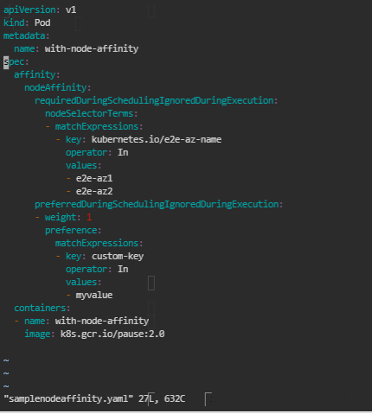

| **Note:** Press ***esc*** button and type ***:wq*** to save the file and exit the text editor. |
| --- |

1. Write the following command to create a pod:

***kubectl apply -f samplenodeaffinity.yaml***



1. Write the following command to describe the pod:

***kubectl describe pod with-node-affinity***

